**Kol simcha torah gazette**

**For parshas acharei mos 5784**

Volume 8 Issue 35 (Whole #393) 3 Iyar 5784/ May 11, 2023

**Printed L’illuy nishmas Nechama bas R’ Noach, a”h**

For a free subscription, please forward your request to [***keren18@juno.com***](mailto:keren18@juno.com)

***Past emails can be found on the website ShabbosStories.com under Brooklyn Torah Gazette***

**The Legacy of the**

**Ribnitzer Rebbe**

**By Daniel Keren**

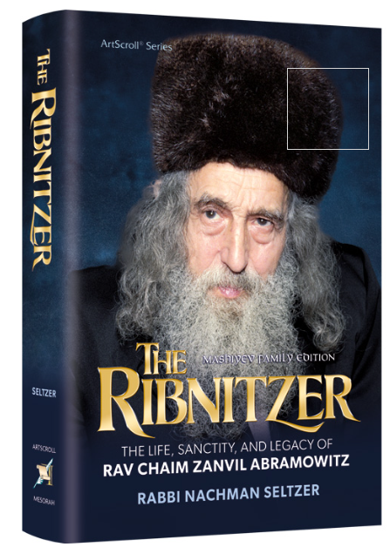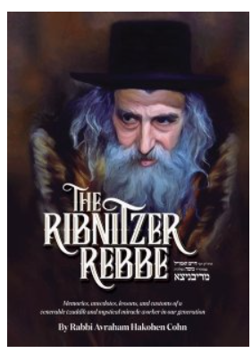

*(“The Ribnitzer Rebbe” by Rabbi Avraham Hakohen Cohn, Israel Bookshop Publications, 272 pages, 2019, translated from the Hebrew book “B’mechitzaso” by Mrs. Esther Perkal and edited by Dr. Jeffrey Solomon.)*

*(“The Ribnitzer: The Life, Sanctity, and Legacy of Rav Chaim Zanvil Abramowitz” by Rabbi Nachman Seltzer. ArtScroll/Mesorah, 392 pages, 2023).*

Hope you, your family and friends had a wonderful and inspiring Pesach. For me, the Festival of Our Freedom was a time to get away from the pressures of work and enjoy time with family. It was also a time to learn seforim (Torah books) in depth that one doesn’t have the time to do so during the regular year. And it was also a chance to read in some of the Jewish magazines about life for Jews in far-off Namibia in Southwest Africa and Uruguay in South America in-between Argentina and Brazil.

**Capturing the Excitement of a 20th Century Tzadik**

With plenty of free time when not davening (praying) and reciting Tehillim in a relaxed manner, I noticed the recent ArtScroll book on the Ribinitzer in my daughter’s house that my son-in-law had purchased. I picked it up and found myself caught up in the wonderful writing style of Rabbi Nachman Seltzer, a very prolific author who brilliantly captures the excitement of one of the great tzadikim (righteous Jews) of the 20th Century – Rabbi Chaim Zanvil Abramowitz, zt”l.

Who was the Ribinitzer who passed away 23 years ago in 1995? There is a disagreement as to when he was born in the Romanian town of Botoshon that is not too far from the old Tsarist Russian empire. Some sources attribute the birth Reb Chaim Zanvil to 1902, while others claim that he was born in the last decade of the 19th Century. Either way, his father died when he was a young boy and his mother brought him to Rabbi Avrohom Matisyohu Friedman of [Shtefanesht](https://en.wikipedia.org/wiki/Shtefanesht_(Hasidic_dynasty)) (1848-1933), where the great Chassidic master who was childless raised him as his own son.

Not surprisingly under the tutelage of the Shtefanesht tzaddik, the future t Rebbe became a child and later a young man devoted totally to the pursuit of dveikus, striving to cleave to Hashem. He would study Torah and become a baki (master) of both the revealed and esoteric parts of the Torah. He would fast every weekday and break his fast at around one or two o’clock in the morning after an exhausting session Tikkon Chatzos (mourning for the destruction of the Beis Hamikdosh, our holy Temple in Jerusalem.)

**A Life of Mesiras Nefesh in Communist Russia**

After the First World War, Reb Chaim Zanvel found himself in Russia now under Bolshevik tyranny and unlike many rabbis who ran away to freedom in other countries, he remained and devoted his life for the next half century to mesiras nefesh (physical self-sacrifice) in encouraging his fellow Jews to uphold whatever Yiddishkeit they could. He performed secretly thousands of bris milahs (circumcisions) in which his life and that of the parents of the boys he brought into the covenant were at great risk. The Ribinitzer also served as a shochet to provide kosher meat, another crime punishable by long sentences to imprisonment in Siberia where all too many Jews never came back alive.

Perhaps even more characteristic of the Ribinitzer was his commitment to daily toiveling (immersing) into the mikvah waters to purify himself [in order to come closer to the Holy One blessed be He], sometimes numerous different times in the same day. And each time he immersed in the mikvah it wasn’t just for a few dips, but rather for some kabbalistic mystical reason – 310 dips in each immersion.

What made Reb Chaim Zanvel’s toiveling even more a memorable example of mesiras nefesh was the fact that the Soviet Communists outlawed mikvahs and the only the way the Ribinitzer Rebbe could immerse was to jump into the Dnieper River which was good in the summer. But in the winter, when the river froze over, he would have to smash the ice with an axe, make a hole and jump into below freezing temperature waters.

Both the books about the Ribinitzer Rebbe by Rabbi Seltzer and Rabbi Cohn are chock-full of inspiring miracle stories about Rev Chaim Zanvel both while he was mesiras nefesh in the Soviet Union and later on after he was allowed to leave Russia in 1970. He lived for a few years in Eretz Yisroel until immigrating to the United States where he first lived in Boro Park, and later on in Seagate in Brooklyn, Los Angeles, Miami and finally in Monsey. Many of these classic Ribinitzer stories can be found in both books. So, you have three choices – buy the original book by Rabbi Cohn, the more recent book by Rabbi Seltzer or buy both books. They are available in Jewish book stores and various online outlets.

*Reprinted from this week’s edition of The Jewish Connection.*

******************************************************************

“Ish / A man–Your father and mother you shall revere and My Sabbaths you shall observe–I am Hashem, your Elokim.” (19:3) What purpose is served by introducing these commandments with the word “Ish” / “A man”?

R’ Yehoshua Kaniel z”l (1895-1970; Chief Rabbi of Haifa, Israel) explains, based on a comment by R’ Yaakov Kranz z”l (1741-1804; Dubno Maggid):

A person may say, “When I was a child, I definitely needed my parents and therefore had an obligation to honor and revere them. Now, however, I am an independent adult! Why should I revere my parents?” To counter this, the Torah begins the commandment with “Ish.” Even when you are a grown person, you shall revere your parents.

Similarly, continues R’ Kaniel, a person might say:“I am an adult with responsibilities. I have a family to feed. How can I refrain from working on Shabbat?” No! says the Torah. “Ish”–even a grown man with mouths to feed should observe My Shabbat. Why? Because “I am Hashem, your Elokim”–I make the rules, and I care for you. (Divrei Yehoshua II)

*Reprinted from the Parshas Kedoshim 5784 email of R’ Yedidye Hirtenfeld’s whY I Matter, the parsha sheet of the Young Israel of Midwood in Brooklyn.*

**Rav Avigdor Miller on**

**Whom Do We Have to**

**Love More, G-d or man?**

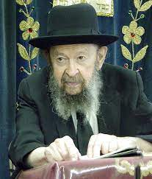

Question: We have an obligation to love Hashem and to love our fellow Jews. Whom do we have to love more, G-d or man?

ANSWER: You have to love Hakadosh Baruch Hu b’chol livavcha, with all your heart so that leaves no space for any competition. Only that Hakodosh Boruch Hu says that you have to obey Him and He says to love your fellow Jews. Part of loving Hashem with all your heart is loving your fellow Jew.

If a person, however, forgets about Hashem and he thinks he’ll concentrate with all his heart on loving his fellow man, that man is wasting his life. And so, it’s a great thing to love your fellow man but that’s only if you do it in the service of Hashem.

You know, we are told that the Chofetz Chaim was a very kindly man. He went out of his way to help people. But he wasn’t exceptional in inviting people to his home. He used to help people find places to stay. He used to pay money to support them when they were visiting his town. He paid for their lodging, for their food. But to take people into his home, he didn’t do that if someone else could do it – he wasn’t so generous. And somebody explained that this was because he didn’t want to divide his loyalties to Hashem. He couldn’t be a crony, he couldn’t sit around all evening talking with his guests. He wanted to spend his time studying the Torah or to be in solitude with Hakodosh Boruch Hu.

A man who is in love with Hashem can’t share his time freely with other people. And so, although the Chofetz Chaim’s heart was in gemilas chassadim. He did all the good deeds that you can imagine. But he did it because of ahavas Hashem. And so, he didn’t spend much time with other people; if he could avoid being a crony and hanging around together with people, that’s what he did. Because to do otherwise detracted from his loyalty, his allegiance and his clinging to Hashem. And therefore, there’s no question about the answer:

ְYou have to love Hashem with all your heart means that there’s no room for anything else.

Kol levavacha means with all your heart, with no divided loyalties.

*Reprinted from the Kedoshim 5784 email of Toras Avigdor, based on the teachings of Rav Avigdor Miller, zt”l. Adapted from Tape #555 (June 1985).*

**The Significance of a “Jewish” Brother**

“Do not hate your brother in your heart.” (19:17) There are many different words to describe the next person. Your friend, a person, a neighbor, a stranger – are some of the ways we can describe an individual. In this pasuk the Torah uses the word brother.

The Torah is telling us - that when a person does something bad to you - you might not consider him your friend. You might not want to consider him your neighbor. You might not even consider him to be a person. But remember he is your brother.

Just like one cannot disown a brother, one cannot disown a fellow Jew. (Rabbi Samshon Refoel Hirsh)

*Reprinted from the Parshas Kedoshim 5784 email of R’ Yedidye Hirtenfeld’s whY I Matter, the parsha sheet of the Young Israel of Midwood in Brooklyn.*

**Pursuing the Goal of**

**Befriending G-d**

**From the Teachings of the Lubavitcher Rebbe**

**Rabbi Menachem Mendel Schneerson, Zt”l**

**Adapted by Rabbi Eli Touger**

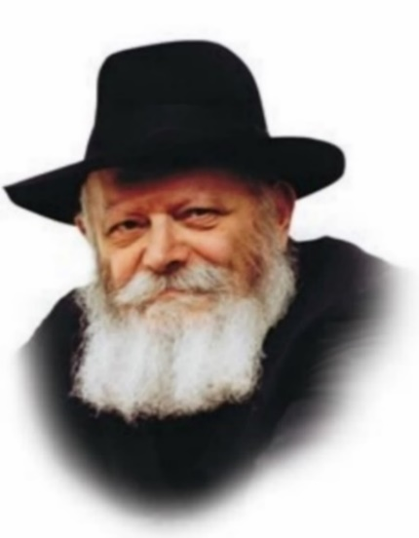

The great saint, R. Yisrael of Ruzhin, and several of his chassidim stopped at an inn to spend the night. On the following day, one of the followers noticed that the innkeeper was busying himself with various chores before reciting his morning prayers.

“Perhaps you should pray?” one of the chassidim ventured.

“There are great Rebbes who also pray late,” the innkeeper responded.

The chassid responded with a parable: “When your wife serves supper late, you get upset. If, however, she serves you a special meal, meat and vegetables sumptuously prepared, you’re willing to forgive her for the delay. If, however, all she serves is simple borsht, you’ll feel justified in becoming angry.”

The innkeeper retorted quickly: “When you really love your wife and she loves you, you’re never upset, no matter what or when she feeds you.”

There are commentaries that interpret the verse from this week’s Torah reading, “Love your neighbor as yourself,” as referring to G‑d. Implied is that [G‑d](https://www.chabad.org/library/article_cdo/aid/433240/jewish/God.htm) is like a beloved friend with whom we share a deep and all-encompassing relationship, a bond that encompasses not only the way we pray and study, but also the manner in which we carry out all aspects of our lives.

**Parshas Kedoshim**

Our [Torah](https://www.chabad.org/library/article_cdo/aid/1426382/jewish/Torah.htm) reading begins with the charge “Be holy,” but it continues with a variety of commandments including prohibitions against theft, lying, gossip, intermingling species of animals, eating produce before the plants which bear it mature, and giving the guidelines for marital relations and the foods we eat.

Implied is that the holiness the Torah asks of us is not otherworldly, but instead anchored in the day-to-day routines of life. Judaism does not want us to be angels, but rather holy men and women, people who live in touch with material reality and control their involvement with it, rather than letting it control them.

Within every element of existence, there is a G‑dly spark. Being holy means seeking to tap that G‑dly energy instead of becoming involved with the entity’s material nature.

We have a natural tendency to polarities: either to seek gratification through indulgence in material pleasures or to renounce them and search for spiritual fulfillment in an ascetic lifestyle.

In the long run, however, neither of these approaches is satisfactory, not for man, nor for G‑d. G‑d certainly does not appreciate material indulgence. And ultimately, man is also not satisfied with that. Deep inside, man wants something more from life than having his desires gratified. Eating, drinking, and other sensual pleasures cannot provide him with the lasting and meaningful satisfaction he is looking for.

**Denying Man’s Natural Instincts**

On the other hand, asceticism is also not an answer. First of all, from man’s perspective, it denies natural instincts. Every one of us has a gut feeling that if G‑d did not want these instincts to be expressed at all He would not have given them to us. If He wanted us to be angels, He would have made us that way. If He made us with physical bodies and material tendencies, it seems obvious that they are also part of His intent.

That’s why asceticism is not acceptable for G‑d either. Our Sages say that He created the world because He desired a dwelling in the lower realms. In other words, the material dimension of our existence is an integral element of His will to create.

On the other hand, He did not create material existence for the sake of indulgence. He invested Himself in the material realm, infusing sparks of holiness into every material entity. What He desires is that we uncover those sparks by using the material entities for His intent.

But how can man know G‑d’s intent? Using his own intuition alone, it is a difficult and perhaps impossible task. For we are mortals and cannot really be expected to know how to appreciate and tap the spiritual energy He endowed to all entities.

For that reason, He gave us the Torah. The very name Torah comes from the word *horaah* meaning “instruction.” The Torah is a guidebook showing us which material entities can be elevated and how they can be refined. The *mitzvos* and prohibitions it contains provide us with advice and direction in our efforts to tap the G‑dliness present within the world around us. In particular, the wide range of subjects discussed in *[Parshas](https://www.chabad.org/parshah/default_cdo/aid/6232/jewish/Parshah-Weekly-Torah.htm" \o "Parshah (Weekly Torah)) Kedoshim* offer guidance in how to reveal the holiness present in a broad spectrum of material activities.

**Looking to the Horizon**

The ultimate fusion of the material and the spiritual will come in the era of the Redemption. At present, we know that every material entity contains sparks of G‑dliness, but that knowledge is merely intellectual. When we look at the material entity, we see only its bodily form. In the era of the Redemption, that will change as Maimonides says: “The sole occupation of the entire world will be to know G‑dliness.” Material reality will continue to exist — we are not speaking of a world of souls without bodies — but its connection to the spiritual will be readily apparent. We will be able to appreciate the G‑dly energy that grants life to every creation.

Describing the nature of the reality that will prevail during the era of the Redemption is not intended merely to arouse our desire for the advent of that era. Instead, it gives us the potential to anticipate that era by living our lives in that spirit in the present age.

That endeavor will precipitate the blossoming forth of this truth into manifest reality. For when man turns his attention to the G‑dliness embedded into creation, that G‑dliness becomes more evident and overtly recognizable.

*Reprinted from “Keeping in Touch – Volume 2” (Sichos in Englishs) adapted by Rabbi Eli Touger, the late Chief Rabbi Emeritus of Great Britain and the Commonwealth*.

**Rabbi Berel Wein on**

**Parshat Kdoshim 5784**

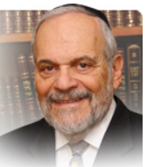

The Torah’s definition of holiness and sanctity, of dignity of self and others, of respect to one’s body and that of others, is in the ability to channel and control one’s physical desires. The Torah explicitly does not condone celibacy nor does it demand from human beings any degree of self-mortification or masochism. It does most certainly demand from us responsible and balanced human behavior.

It outlines a necessary and omnipresent nuance in our lives - in our mental and physical behavior. The rabbis have taught us that humans willingly sin only because a manner of distorted thinking -a type of insanity if you will - enters one’s mind and being.

Judaism has always fought the lonely and mainly unpopular battle against sexual immorality and flagrantly wanton behavior. From the Canaanites through the Greeks and the Romans, the debauchery of much of the Medieval Age and the current unchecked and unrestrained attitudes of modern society, traditional Judaism has decried lewdness and wanton self-gratification in sexual matters.

It has demanded that people be *kdoshim* - separated from immoral behavior and forbidden liaisons. It demands self-control, the avoidance of compromising and dangerous situations and a realization that ultimate good sense should triumph over momentary gratification.

Judaism imposes on us an unpopular stance, especially so in our current modern society. And yet over the long history of human society, it has proven to be the only correct guide for a healthy, happy family life and a more harmonious social compact between people.

Many people, Jews included, mock the protective measures enjoined by Jewish tradition to insure a society that aspires to be one of *kdoshim*. The mingling of the sexes in synagogue worship in the non-Orthodox world has not brought any great degree of comfort to those people who sit together. It has rather led to a drastic decline in synagogue attendance and participation in those groups.

The whole concept of modesty in dress, speech and behavior is unfortunately completely absent and alien in most of modern society. Not a day passes when we are not made aware of the presence of sexual misconduct among those that seemingly should know better.

Judaism preaches defensive behavior and the avoidance of situations that could lead to problematic circumstances. Such defensive measures are mocked and scorned by the progressives of the current world. Yet we are witness to the tragic personal and national consequences that results in life when such defensive measures are absent or ignored.

Mental health experts have told me that pornography, especially on the internet, is the newest serious addiction in our schools, making drugs old hat and no longer cool.  Protected by the noble ideal of free speech, it ravages our society and creates a dangerously dysfunctional generation and society.

The entertainment industry in all of its facets has been polluted beyond recognition by its pandering to the basest animalistic desires of humans. Nevertheless, the Torah does not waver in its demand to us to be *kdoshim*, to swim against the tide and persevere in our age-long quest to be a holy and dedicated people.

Shabbat shalom.

*Reprinted from the current website of rabbiwein.com*

**The Jewish Story of the**

**UNC Frat Boys Who Held**

**Up the American Flag**

**Bt Fatgue Levy Holt**



**A dozen members of the Jewish fraternity AEPi were among the young men who held the American flag aloft after anti-Israel protesters tore it down.**

*Credit: Parker Ali/Daily Tar Heel*

Images of a small group of students at the University of North Carolina in Chapel Hill holding up an American flag amid violent anti-Israel protests last week captured the attention of the nation. The boys were caught on camera struggling to keep the Stars and Stripes from falling onto the ground after the protesters sought to replace it with a Palestinian flag.

What isn’t as widely known is that about a dozen of the 25 or so students who kept the American flag flying were young Jewish men—brothers from the Jewish fraternity Alpha Epsilon Pi, or AEPi—and members of Chabad-Lubavitch at UNC. All of them participate in Fra-Torah, a weekly Torah class at Chabad, attend Friday night Shabbat dinners, and are part of [Chabad](https://www.chabad.org/library/article_cdo/aid/244369/jewish/About-Chabad-Lubavitch.htm) at UNC's Lions of Israel *tefillin* club.

Among them was 19-year-old Jacob Harris, who [told Chabad.org](https://www.chabad.org/news/default_cdo/jewish/News.htm) that while he didn’t initially plan to challenge the protesters, when he heard that friends and other supporters of Israel and the Jewish people’s rights to dwell there were being called “fascists and Nazis,” and worse, he had to do something.



**Chabad at UNC is directed by Rabbi Zalman and Yehudis Bluming. Their son is pictured helping a Jewish student put on**[**tefillin**](https://www.chabad.org/library/article_cdo/aid/1918251/jewish/What-Are-Tefillin.htm)**on campus amidst the antisemitic and often violent protests.** *Credit: Chabad at UNC.*

“I realized these protests had evolved. For the first time here in college, I felt as if my presence at my university as a Jewish student was being scrutinized,” Harris said.

Joining up with a few friends, Harris went to the quad—the central area on campus—carrying an Israeli flag. What he saw when he arrived upset him deeply.

“We watched in horror and disgust as the protesters tore the American flag in the center of the quad off its pole and replaced it with a Palestinian one,” he recounted. “This demonstration had become completely out of hand.”

Police arrived soon after, and the American flag was returned to its rightful spot. However, once the authorities left, protesters again targeted the flag.

That was when Harris and his friends jumped into action. They encircled the flagpole and held the American flag aloft over their heads to ensure that it didn’t touch the ground. Photos of the young men standing proud in the face of blatant hate quickly spread across the country.

“The scene that stood before us was just awful,” said Harris. “The same people that had promoted their protest as peaceful were pelting us with all sorts of projectiles—a metal water bottle gave my friend a black eye simply for standing up for his identity and defending the Stars and Stripes.

“The American flag is a symbol of freedom—the freedom represented by that flag allows me to express my identity just as it allows individuals to protest. Seeing the flag being taken down by the same people that it gives the right to protest felt like a slap in the face of every American citizen,” Harris said.

**‘Standing Up for What They Believe In’**

Rabbi Zalman Bluming, co-director with his wife, Yehudis, of [Chabad at UNC at Chapel Hill](https://www.chabad.org/jewish-centers/118525/Chapel-Hill/Synagogue/Chabad-of-Durham-Chapel-Hill), wasn’t surprised to see the young men jump into action.

“[They] have in spades what so many of their peers are sorely lacking: common sense, love of their country and a willingness to defend it,” he said. “Moreover, these boys see one another as brothers and defend their highest common commitments as brothers should. We Jews will stand up for America’s flag when others are prepared to trample it. And our true brothers in this great country stand united with us.”

While some have sought to define the violent protests on campus as one of fighting oppression, those who have gone to the encampments and watched the protests say there’s much more going on.

“This is an American fight,” Bluming said. “It’s not just Jewish values being threatened on campus; it is American freedom and American values. There is a tremendous synergy between Jewish values and American values, and I am very proud of what these young men did in standing up for what they believe in.”

He added that Judaism encourages people to be upright and upstanding citizens, to take part in their communities and support their government, something he said [the Rebbe, Rabbi Menachem M. Schneerson](https://www.chabad.org/therebbe/default_cdo/jewish/TheRebbeorg.htm), of righteous memory, encouraged. “[He wanted people to go vote](https://www.chabad.org/therebbe/article_cdo/aid/2981559/jewish/Voting.htm), to be involved in civic service,” said the rabbi. "The boys weren't wearing *tefillin* at the time, but I believe that's where they get the strength to stand up for what they believe and be successful doing so.

*Reprinted from the current website of Chabad.Org*